Lab 2 – Viewing Network Device MAC Addresses
Chapter 5 Activity
Student ID | Student Name
32163 | Aya Haddara
32234 | Mira Wehbe
32038 | Ranim Toutanji
32554 | Nour Hazm Bakry
32656 | Amina Ibrahim
30930 | Mohamad Mostafa
32169 | Abdelhalim Kouchaji
31567 | Wael Taleb
32720 | Diyaa Hamdan
30627 | Ibrahim Rabih
31970 | Asaad al Asaad

Objectives
In this lab, we configured a Cisco Catalyst switch and a PC to communicate on a local network. We used commands on both devices to display, describe, and analyze Ethernet MAC addresses, including identifying the OUI vendor prefix and the device serial number portion. We also examined how MAC addresses are stored in the switch MAC address table and how they map to IP addresses using ARP.

Required Resources
- 1 Switch (Cisco Catalyst 2960 with Cisco IOS Release 15.0(2) lanbasek9 image or comparable)
- 1 PC (Windows 7 or 8 with a terminal emulation program, such as Tera Term)
- Console cable to configure the Cisco switch via the console port
- Ethernet cables as shown in the topology

Part 1: Configure Devices and Verify Connectivity
Step 1: Cable the Network
We attached the Cisco Catalyst switches in the rack and connected the console cables as required. The PC was connected to the switch via an Ethernet cable on port Fa0/1.
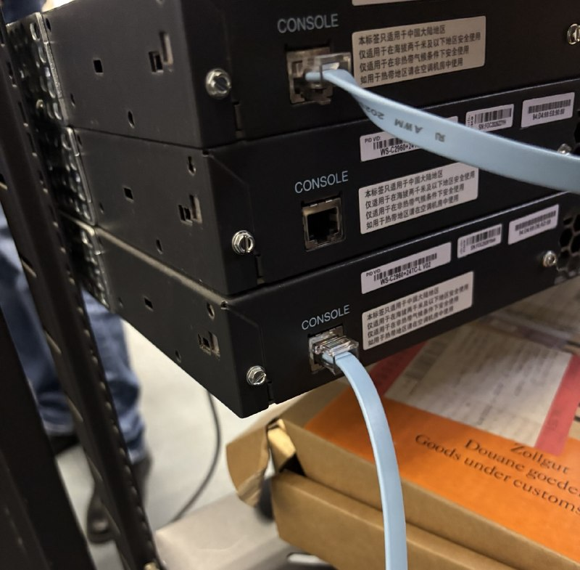
Figure 1: Physical setup – Cisco Catalyst switches in rack with console cables connected
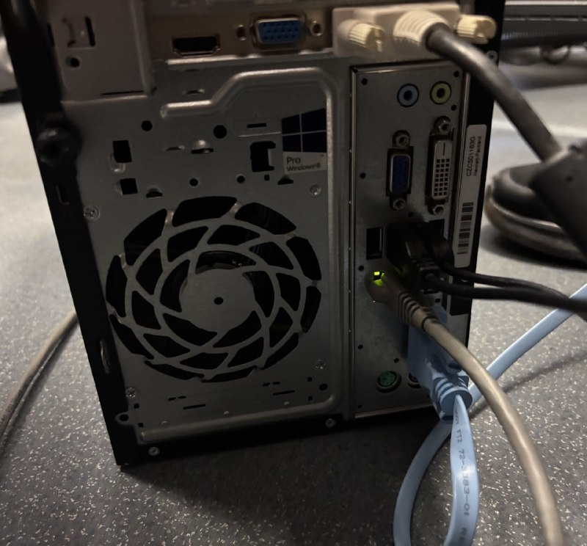
Figure 2: Back of PC showing Ethernet cable connected to NIC port (green link light active)
Step 2: Configure the Switch (S2) – VLAN 1 Interface
We connected to S2 via console, entered global configuration mode, and configured VLAN 1 with IP address 192.168.1.2 / 255.255.255.0. We then issued 'no shutdown' to bring the interface up.
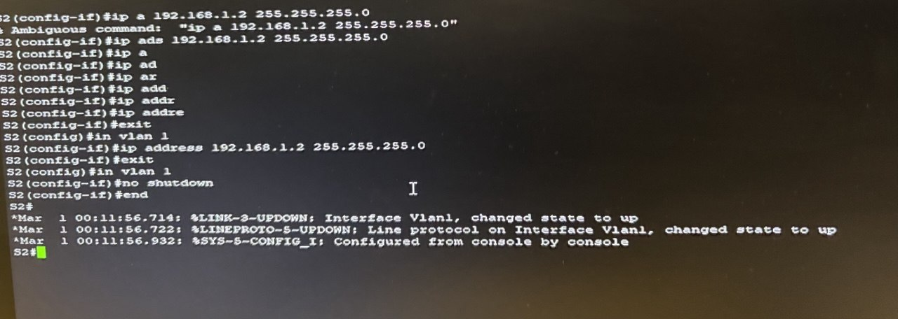
Figure 3: S2 CLI – Configuring IP address 192.168.1.2/24 on interface VLAN 1 and enabling it with 'no shutdown'
Step 3: Verify Network Connectivity
After configuration, we tested connectivity by pinging the switch from the student PC and from the Admin PC. Results are shown below.
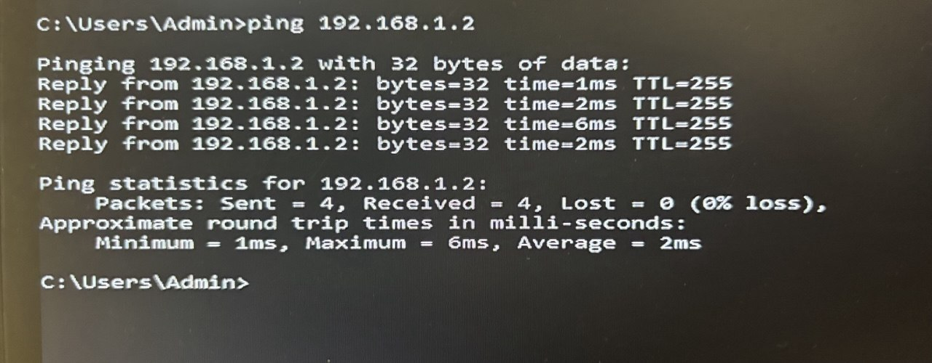
Figure 4: Ping test from Admin PC to S2 (192.168.1.2) – 4/4 replies received, 0% packet loss
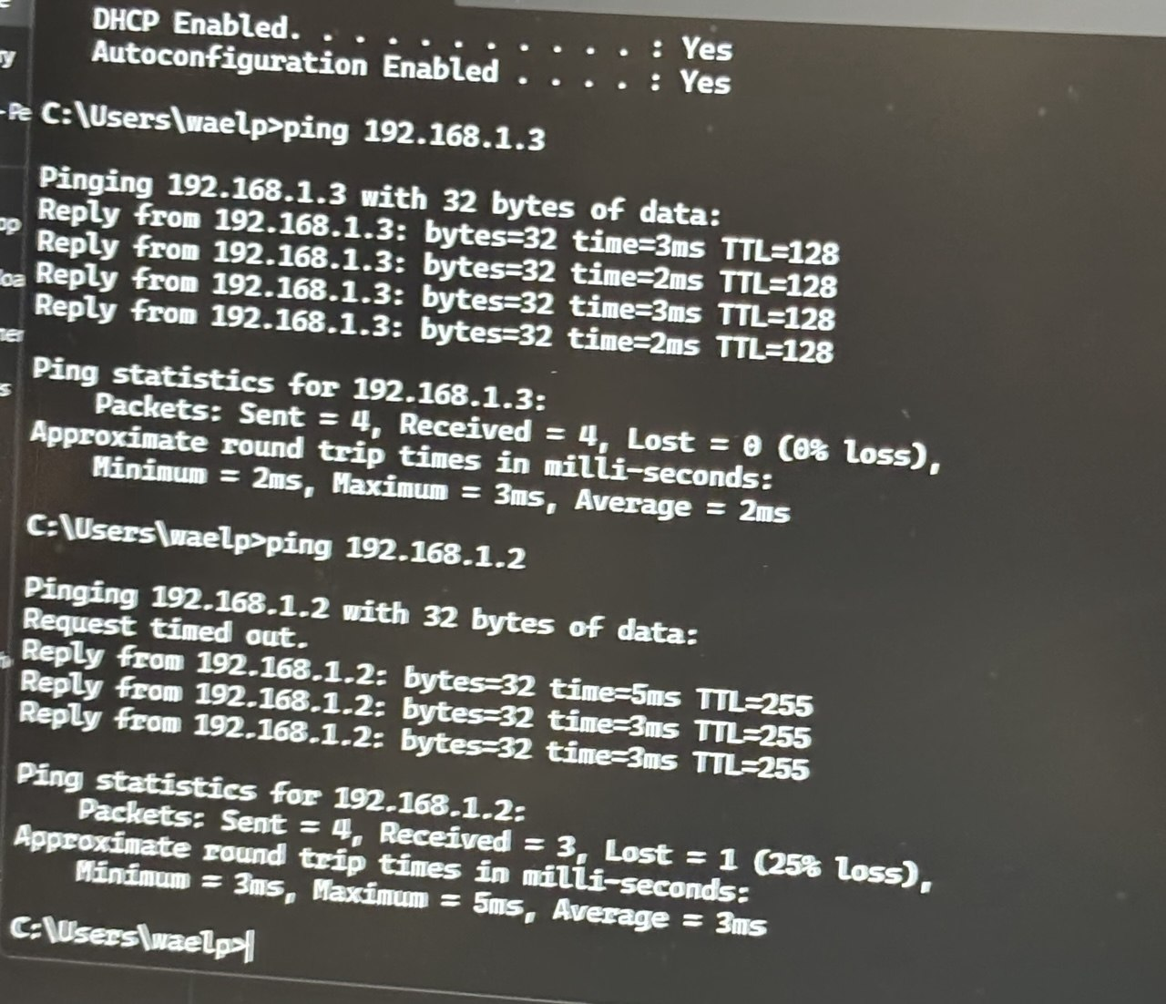
Figure 5: Ping from student laptop to 192.168.1.3 (PC) and 192.168.1.2 (switch)
The pings to 192.168.1.3 were fully successful. The first ping to 192.168.1.2 had one timeout because ARP had not yet resolved the switch MAC address — subsequent replies succeeded. This confirmed correct connectivity across the network.
Part 2: Display, Describe, and Analyze Ethernet MAC Addresses
Ethernet MAC addresses are 48 bits long, displayed as six sets of hexadecimal digits. The first three bytes (OUI) identify the manufacturer; the last three bytes are the device serial number assigned by the manufacturer.
Step 1: Analyze the MAC Address for the S2 VLAN 1 Interface
We issued the 'show interfaces vlan 1' command on S2 to find the hardware MAC address of the switch VLAN 1 interface.
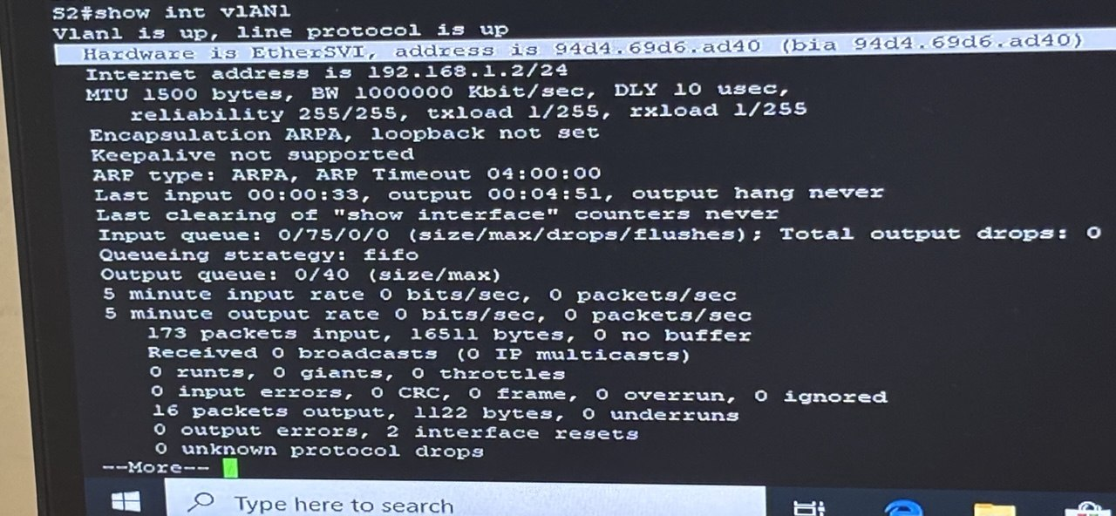
Figure 6: S2 – 'show interfaces vlan 1' output – Hardware address is 94d4.69d6.ad40, IP 192.168.1.2/24
Field | Value | Notes
Full MAC Address | 94d4.69d6.ad40 | BIA = burned-in address
OUI (first 3 bytes) | 94:d4:69 | Cisco Systems, Inc.
Serial (last 3 bytes) | d6:ad:40 | Device NIC serial number
The 'bia' (burned-in address) shown in parentheses is the factory-assigned MAC address permanently stored in hardware. It appears twice because Cisco IOS shows both the active address and the original burned-in address — they are identical unless a MAC override has been configured.

We entered the switch OUI into the MAC vendor lookup tool to confirm the manufacturer:
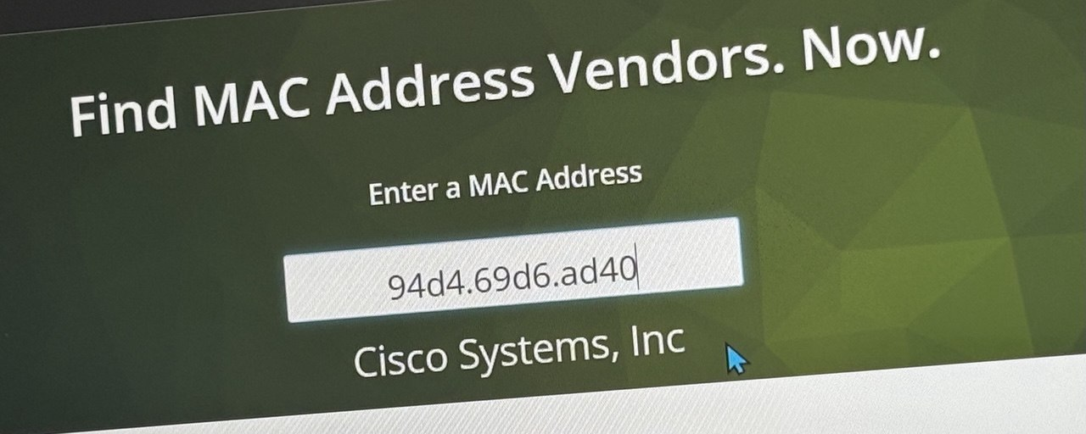
Figure 7: MAC lookup for switch MAC 94d4.69d6.ad40 – Vendor identified as Cisco Systems, Inc.

Step 2: Analyze the MAC Address for the PC-A NIC
Using 'ipconfig /all' on PC-A, we identified the NIC MAC address as a0:d3:c1:4f:87:d8. We entered the OUI portion into the MAC vendor lookup tool:
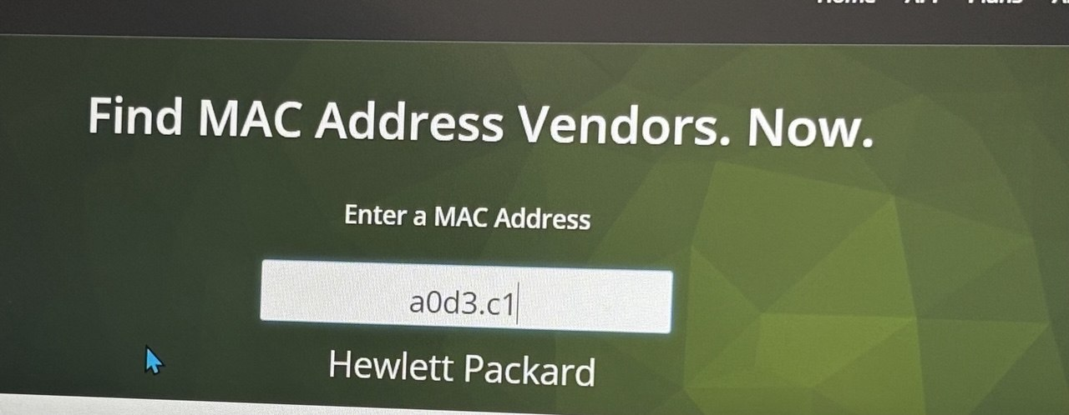
Figure 8: MAC vendor lookup for PC NIC OUI a0d3.c1 – Vendor identified as Hewlett Packard
Field | Value
OUI (first 3 bytes) | a0:d3:c1
Serial Number (last 3 bytes) | 4f:87:d8
Vendor | Hewlett Packard

Step 3: Use 'show ip arp' to Display MAC-to-IP Mapping
We used the 'show ip arp' command on S2 to display the ARP table, mapping Layer 2 MAC addresses to their corresponding Layer 3 IP addresses:
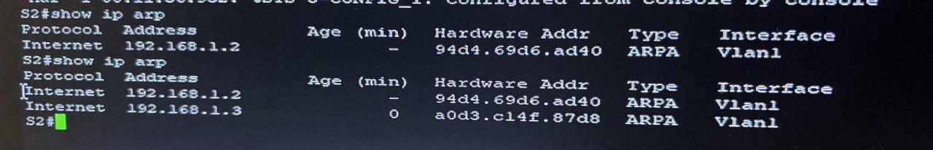
Figure 9: S2 – 'show ip arp' output – ARP entries for 192.168.1.2 (switch) and 192.168.1.3 (PC-A)
IP Address | MAC Address | Device
192.168.1.2 | 94d4.69d6.ad40 | S2 – VLAN 1 (Cisco)
192.168.1.3 | a0d3.c14f.87d8 | PC-A NIC (Hewlett Packard)

Step 4: View the MAC Address Table on S2
We issued the 'show mac address-table' command on S2 to see all learned and static MAC addresses:
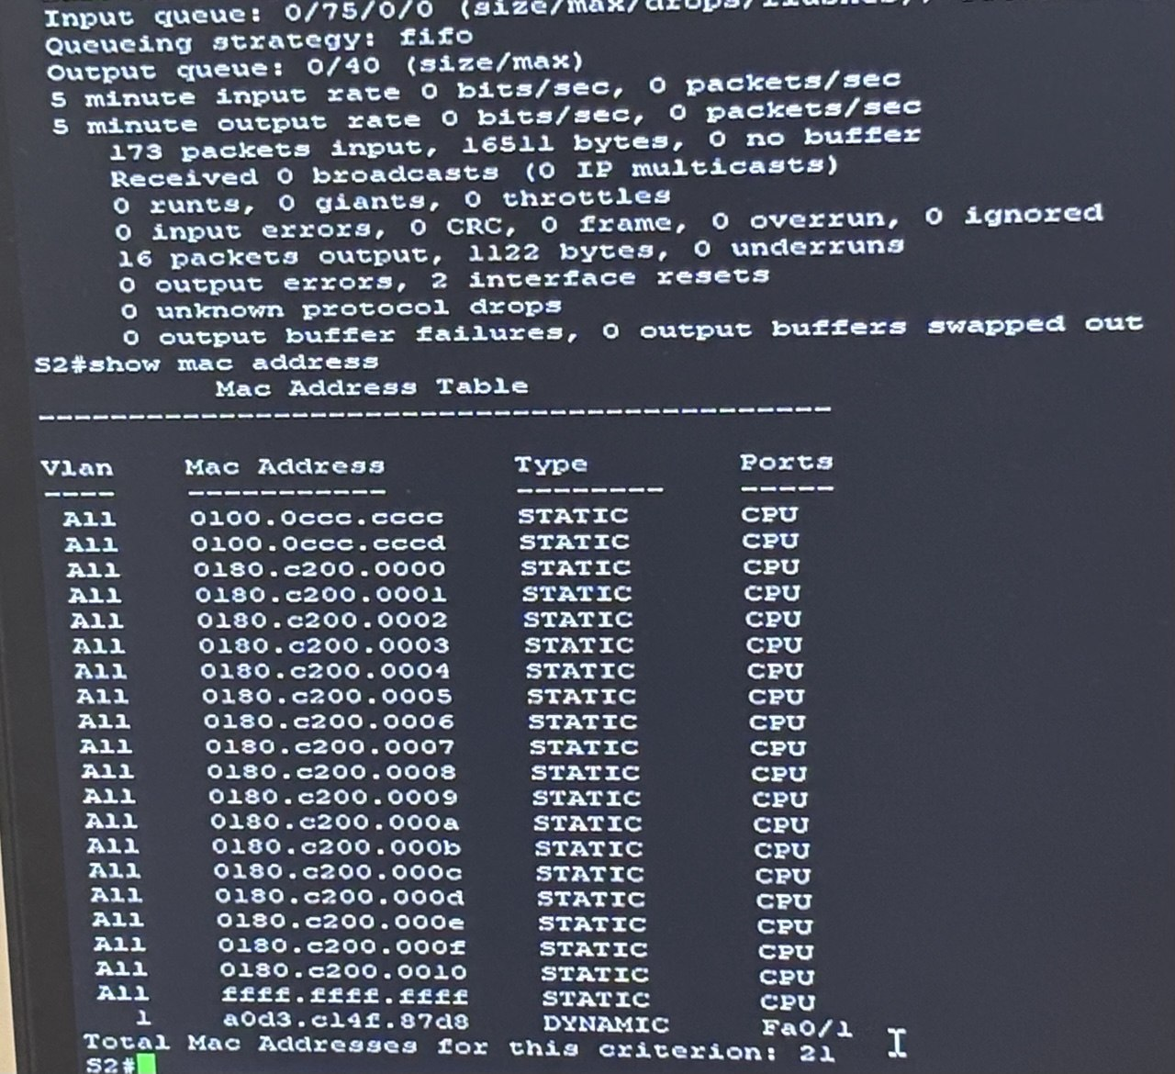
Figure 10: S2 – MAC address table showing 20 static CPU entries and 1 dynamic entry (PC-A on Fa0/1)
The switch dynamically learned PC-A's MAC address (a0d3.c14f.87d8) on VLAN 1, port Fa0/1. All other entries are STATIC and belong to internal CPU processes. Total MAC address count: 21.
Reflection
1. Can you have broadcasts at the Layer 2 level? If so, what is the MAC address?
Yes. Layer 2 broadcasts use the address ffff.ffff.ffff (all 48 bits set to 1). This address appears in the MAC table as a STATIC CPU entry. A frame sent to this address is delivered to every device on the local network segment.
2. Why would you need to know the MAC address of a device?
- Troubleshooting: MAC addresses help identify which physical device corresponds to an IP address, essential when diagnosing connectivity problems.
- Security: Administrators use MAC address filtering on switches and wireless APs to control which devices may join the network.
- ARP analysis: Understanding MAC-to-IP mappings is required when investigating ARP spoofing attacks or unexpected ARP table entries.
- Asset tracking: MAC addresses uniquely identify NICs, making them useful for hardware inventory management in enterprise environments.
Conclusion
In this lab, we successfully configured Cisco Catalyst 2960 switch S2 with IP address 192.168.1.2/24 on VLAN 1, and PC-A with IP address 192.168.1.3/24. Connectivity was verified via ping from both the Admin PC and the student PC. The initial ARP resolution caused one timeout on the first ping to the switch, which is expected behavior.
We analyzed MAC addresses using 'show interfaces vlan 1', 'show ip arp', and 'show mac address-table'. The switch OUI (94:d4:69) belongs to Cisco Systems, Inc., and the PC NIC OUI (a0:d3:c1) belongs to Hewlett Packard. The BIA is the factory-programmed address stored permanently in hardware. The MAC address table confirmed that PC-A's address was learned dynamically on port Fa0/1.

